|  |  |
| --- | --- |
| **Programming II**  Diploma in IT / DS / CSF  Year 1 (2021/22) Semester 2 | Week **12** |
| **2** hours |
| **Practical 9: Web API** | |

**OBJECTIVES**

At the end of this exercise, students should be able to:

* Use tools such as Postman to retrieve JSON data from a Web API server
* Send a GET request to retrieve JSON data from a Web API server

|  |
| --- |
| **IMPORTANT**   * Create a folder, **week12** in your hard disk and save all your work in this folder. * Create a new Console App (.NET Framework) project, **Snnnnnnnn_BookApp**, in the **Week12** folder created above *(note:* ***Snnnnnnnn*** *is your Student Number)*. * At the end of the session, copy this folder (all your work) to PRG2 network folder: **\\ictspace.ict.np.edu.sg\PRG2** |

**INTRODUCTION**

Postman is a useful tool used by many developers to document, test and interact with Application Programming Interfaces (APIs). The download is available for Windows, Mac and Linux at <https://www.getpostman.com/downloads>.

Working with Postman makes it very convenient to test and interact with REST APIs. It has capabilities to work with different authentication mechanisms, different forms of data and to import and export API Collections.

In this practical exercise, we are going to implement the Console Project **BookApp**. Before we start coding, we can test out and observed how the JSON Web API is formatted using Postman.

**INSTRUCTIONS**

Start the Postman application and type in the **following URL** on the URL field.

[**https://ictonejourney.com/api/books**](https://ictonejourney.com/api/books)

Click the Send button to send your request. Note the JSON data response from the server.

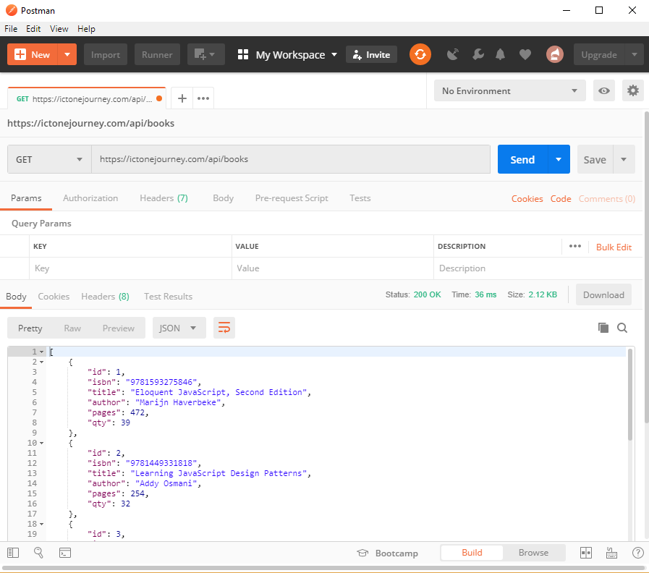

Take a look at JSON data that you have retrieved and appreciate the JSON syntax. You can collapse the various information using thesymbol next to the numbering.

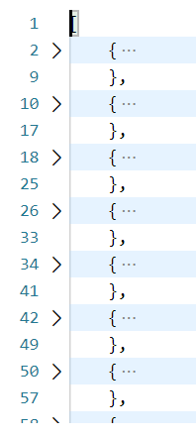

1. The list (array) of books starts with [ and ends with ]. Each Book object, , is separated by comma. How many books are there in this JSON**???** 15

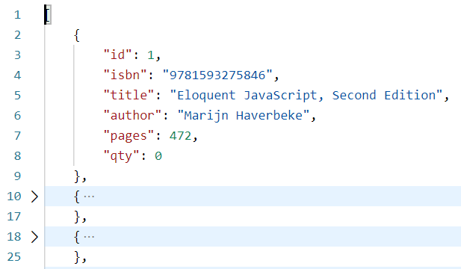

1. Expand the line 2  symbol. The object has SIX key-value pairs, namely “id”, “isbn”, “title”, “author”, “pages” and “qty”.
   1. What is the data type of “isbn” and “title”? string
   2. What is the data type of “pages” and “qty”? integer

**BookApp**

Create the Console App to get and display the book details from the Web API server:

1. Implement the Book class based on the JSON data retrieved from Web API server. The Web API url is [**https://ictonejourney.com/api/books**](https://ictonejourney.com/api/books).

1. Before implement the *Program.cs*, you need to install the Newtonsoft.Json NuGet package into your Console Project. To install the package:
   1. In the Visual Studio 2019, go to Project🡪Manage NuGet Packages…

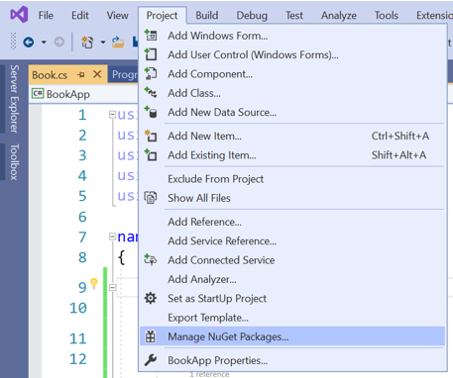

* 1. Choose "nuget.org" as the **Package source**, select the **Browse** tab, search for **Newtonsoft.Json**, select that package in the list, and select **Install:**

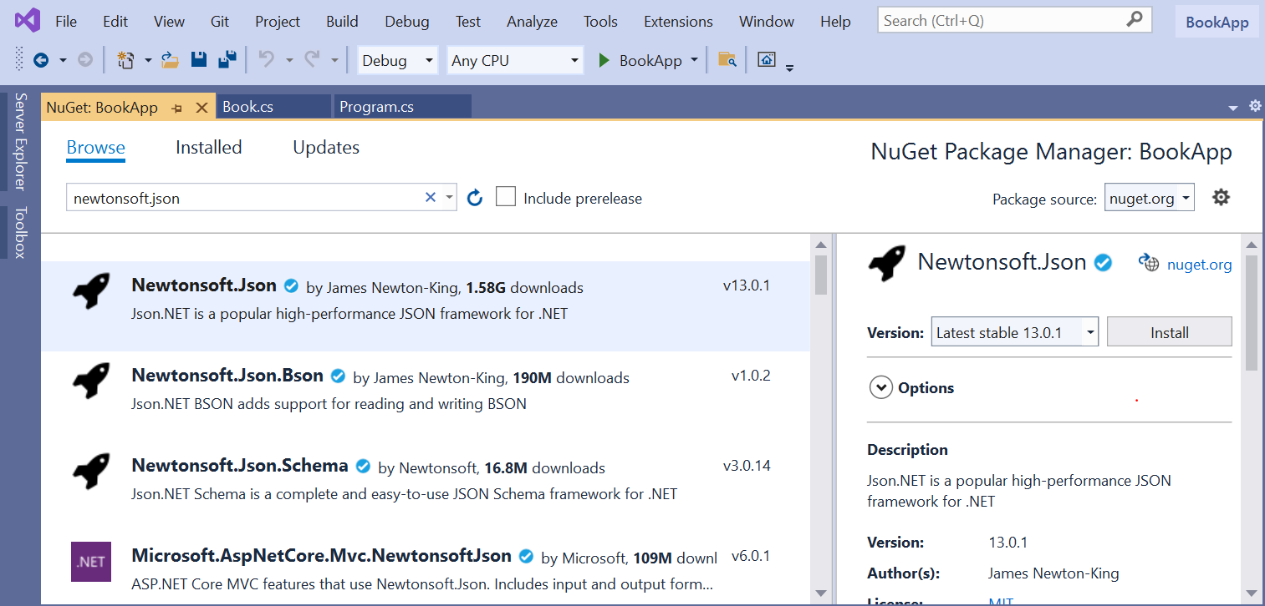

* 1. Click OK to proceed:

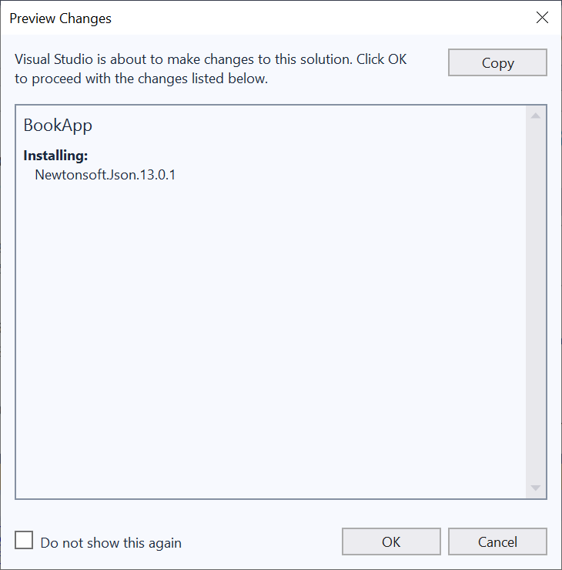

1. Implement the *Program.cs.*

Sample output is shown below:

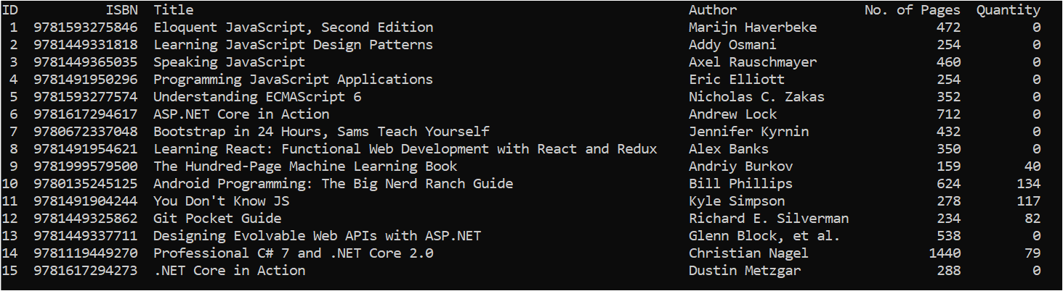

ADVANCED

1. Study the Web API documentation provided in [**https://data.gov.sg/dataset/carpark-availability**](https://data.gov.sg/dataset/carpark-availability%20)

1. Create a new Console Project **CarParkAvailabilityApp** in Visual Studio 2019 to get and display the carpark availability from the above Web API that has between 1 and 10 lots available.

Sample output is shown below:

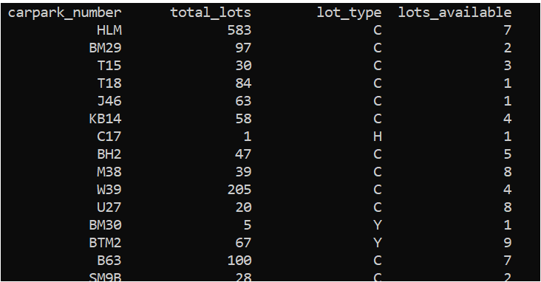

**Note:**

You can use Edit > Paste Special > Paste JSON As Classes in the Edit menu in Visual Studio to convert the JSON data in your clipboard to C# class. Rename the class to your own choice.

Detailed carpark information can be found at https://data.gov.sg/dataset/hdb-carpark-information.

**Plagiarism Warning:**

**If a student is found to have submitted work not done by him/her, he/she will not be awarded any marks for this practical. Disciplinary action may also be taken.**

**Similar action will be taken for student who allows other student(s) to copy his/her work.**